You´re a native application developer now
This guide covers how to create, build and run a simple “hello world” application using Xcode IDE tools. It is a brief tutorial that does not go into details of each tool. You will learn:
- What essential tools you need to know about
- How to create a project and run it on the iPhone simulator
- How to use the instrumentation tools

Objective

This lab will be executed using the iPhone Xcode IDE, this means that all execution will be done in a user interface. You will not be able to do this lab in a Windows environment. In Xcode the build and run option in the IDE starts and executes the compiler, linker, debugger and iPhone simulator in a chain of events which simplifies your work flow.

In this tutorial you will be using a few tools in the iPhone tool chain, these are:

- Xcode project wizard
- The Build and Run tool that starts the GCC Compiler.
- The GDB debugger
- The iPhone Simulator
- We will also look at an instrumentation tool

Requirements

- You need to have the iOS SDK 4.2 installed.
http://developer.apple.com/

Resources and notes

This guide is an abstraction from http://developer.apple.com/ and can be studied more in detail.

How to create a new project

When you start Xcode you will be presented with a few options, click the create new project option and then you will be presented with this dialog. It represents the possible targets and layouts you can chose to make your application. Mark the “Application” under iOS in the top left corner. Then chose a View-based application among the top right templates. Make sure to have chosen the iPhone product in the middle and then click Choose. You will then be prompted for a location of your project structure and a name for it.

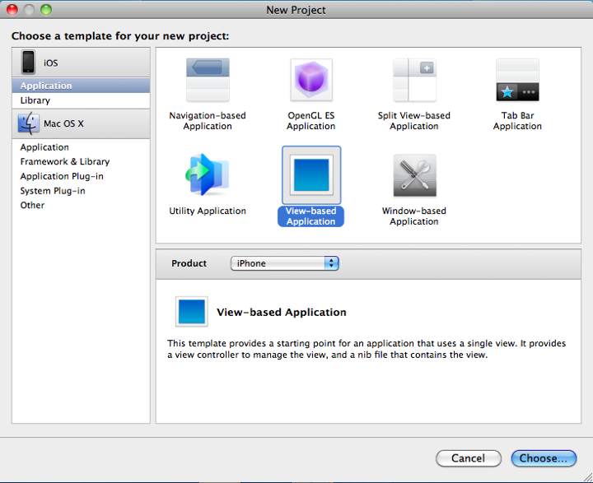

At this point you have now created a number of files and folders in your selected directory that supports the iPhone tool chain. It can look like this:
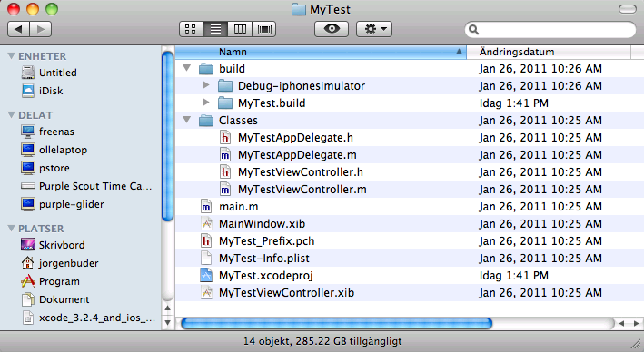
How to build your new project

At this point you will want to try and build the project this is done with the Build and Run icon in the top middle. When you click this icon a number of tools will be running in the background, for instance the GCC compiler, the GDB debugger and eventually the iPhone simulator where you application will be downloaded and run for you. At the bottom of the IDE you can see a status row being updated with whats happening during this process. You should after hitting that button have a iPhone simulator running your empty “hello world” application which is now only an empty shell.

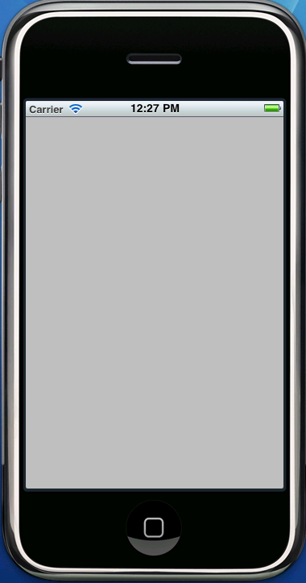

From here you can now go on and start editing your application. In Xcode you have an integrated editor, but you can edit your code with other editors too. Take some time and explore the files in the project and then locate the main.m file. This is where you will begin your iPhone develoment.

Here is the code in the first main instance of your application. The file is located in the root of your project path.

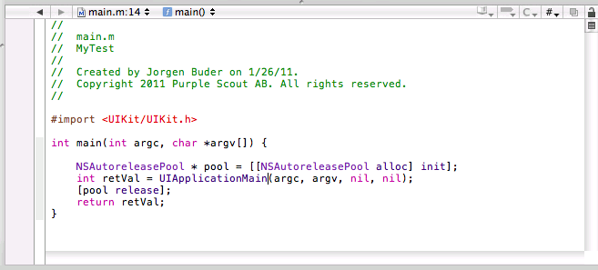
As we only touch the tools here we do not add any code to this project at this time.

Instrumentation.

In Xcode you can find an option where you can run your application with an instrumentation option. Click the run menu and choose run with performance tools/leaks and you will see how your application is launched in the simulator with a tool to see the memory allocations in real time, one of some of the great tools you can find in the Xcode IDE.

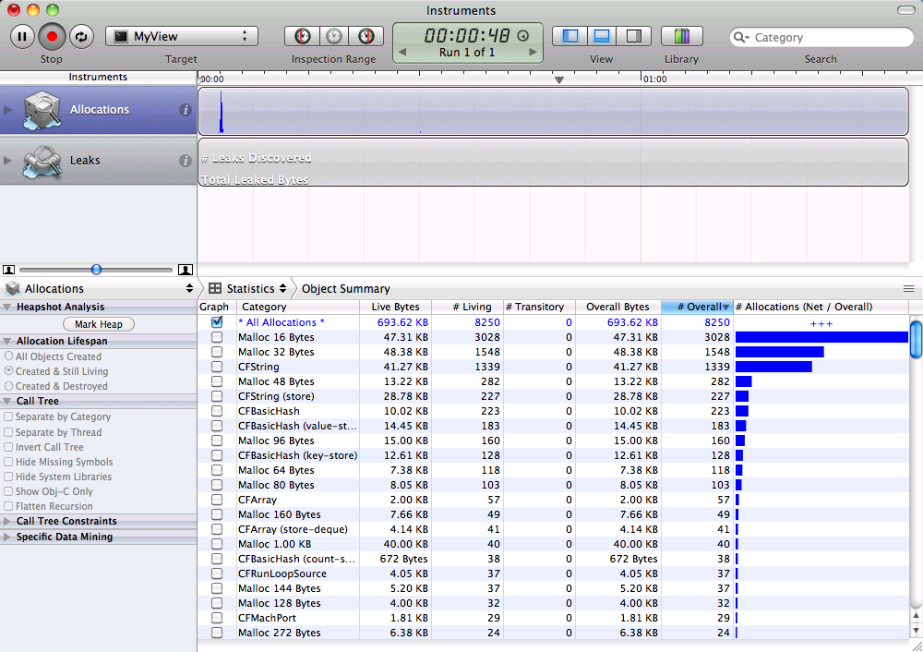

There are a number of instrumentation tools available. You can do things like inspecting your application, view logs, look at threads and depending on your hardware setup simulate things like GPS coordinates or making calls.

Try to start other tools as well and explore them.

Summary

You should now have a brief understanding of the processes of how an iPhone application are build. Please reference the Apple development site for more in depth information.

In this lab you have been introduced to a number of iPhone tools that are critical to the iPhone tool chain. There are a few other tools as well you may need to know about, so here is a list of those and the tools in this lab that you will also find on their site, see link below.

Xcode tools overview can be found here:
http://developer.apple.com/library/ios/#documentation/Xcode/Conceptual/iphone_development/000-Introduction/introduction.html

And here are a more detailed hello world application example if you which to dig deeper:
http://developer.apple.com/library/ios/#documentation/Xcode/Conceptual/iphone_development/100-iOS_Development_Quick_Start/development_quick_start.html#//apple_ref/doc/uid/TP40007959-CH3-SW1

